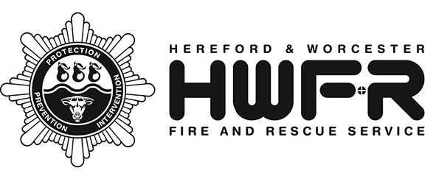
Service
Policy /
Instruction

Joint Protocol for Industrial Relations

Status | Live
Document Version | Version 6.00
Author | Human Resources & Development
SMB Sponsor | Guy Palmer – Assistant Chief Fire Officer
Department | Human Resources & Development
Date Approved | April 2021
Review frequency | 5 Years
Next Review | 08.04.2026

Version History
Version | Date | Description
6.00 | April 2021 | Reformatted and updated RFU name to FRSA
Executive Summary

Hereford & Worcester Fire and Rescue Service (HWFRS) wholeheartedly supports the principle of co-operation between employer, employees and Trade Unions to help ensure the successful delivery of the Service and the management of change. HWFRS has a strong commitment to effective industrial relations, to consultation and negotiation with employees and believes in the principle of resolving industrial relations problems by discussion and agreement. For practical purposes this is conducted through Trade Union representatives and, to this end, employees are encouraged to join and remain in recognised Trade Unions.

Alternative Formats
If you require this document in another format please contact the Human Resources and Development Department.

Service Values
This policy supports our commitment to the Service values.
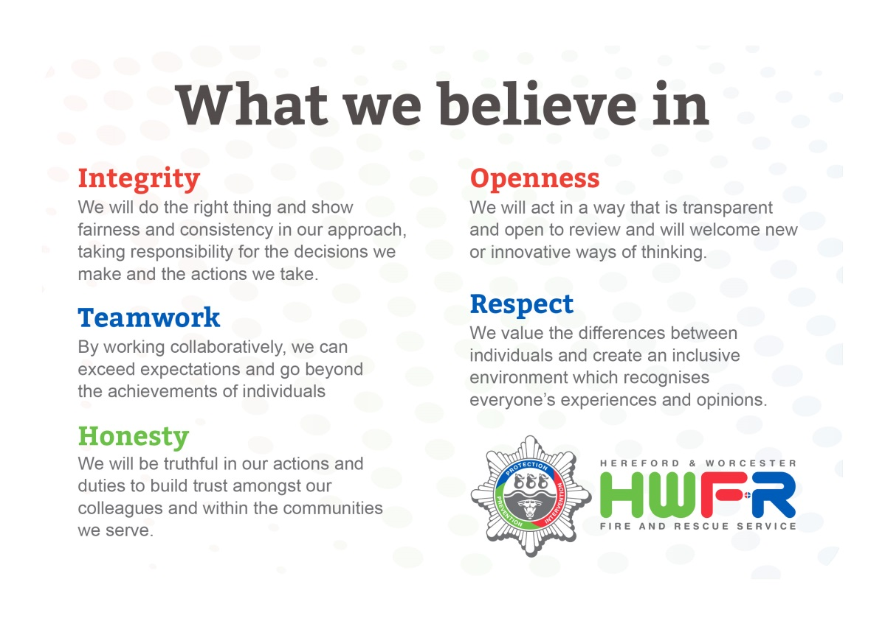
Contents

1 Statement of Principle 4
2 Information 4
3 Consultation 5
4 Negotiation 5
5 Formal Arrangements with the Fire and Rescue Service 5
5.1 Consultation 6
5.2 Negotiation 6
6 Meetings 5
7 Time off for Trade Union Duties and Activities 7
8 Review of Protocol 7

Appendix A
Example Summary of Discussions from JCC Meeting 8

Appendix B
Example JCC Consultation Register & Decision Log 9

Appendix C
Time off for Trade Union Duties and Activities 10

Appendix D
Record of Time off for Trade Union Activities 13

Joint Protocol for Industrial Relations

1. Statement of Principle

  - The framework of communication and consultation detailed in this Protocol reflects the Model Consultation and Negotiation Procedure contained in the Scheme of Conditions of Service Sixth Edition (“the Grey Book”) and in the joint protocol that is contained in National Joint Council (NJC) Circular 08/07 which applies to Uniformed staff other than Fire Service Managers. The protocol for communication, consultation and negotiation applies to all recognised Trade Unions.

1.2 Recognised Trade Unions with HWFRS are The Fire Brigades Union (FBU), Fire and Rescue Services Association (FRSA), The Fire Officers Association (FOA), UNISON and Britain’s General Union (GMB).

1.3 In accordance with the principles of devolved management, the conduct of employee relations and the resolution of day to day issues arising within the workplace should be discussed between managers and local officials/stewards as and when they arise. It is expected that officers and officials who have responsibility for a relevant work area will deal with each category of issue as fully as possible. This helps to clarify and often resolve areas of concern at an early stage. For example, an issue that relates solely to a Station will be dealt with by the Station Commander and Branch Officials. This approach should be sufficient to deal with the vast majority of issues. There may be however, other matters that either because of their significance or, because they have cross service implications, require the involvement of Senior Officials/Stewards or Trade Union Officers and Senior Managers.

1.4 All relevant, non-confidential information will be made available to the recognised Trade Unions to enable meaningful consultation to take place within the confines of both Data Protection Act and Freedom of Information Act statutes.

1.5 For clarification, the terms ‘information consultation’ and ‘negotiation’ are defined in Sections of this Instruction.

2. Information

2.1 To encourage an open and transparent management style, managers will seek to share information with Trade Unions at an early stage, both ensuring that they are appraised of work in progress and provided with an opportunity to contribute informally to the development of proposals at an early stage. This informal information sharing stage does not in any way commit or limit the actions of either managers or Trade Unions, once final proposals move onto the formal consultation or negotiation stage.

2.2 There will be some situations where there is little or no scope for consultation or negotiation but where good management practice would encourage early information sharing. For example, in respect of some statutory/health and safety procedures, employment conditions bound by legislation or national collective bargaining. Whilst there may be no opportunity for further consultation or negotiation on these matters, managers will share information with Trade Unions at the earliest stage possible to ensure that they are kept informed of changes and developments which affect their members.

2.3 From time to time there will be a requirement to make minor amendments to existing orders or procedures where the nature of that change does not require further formal consultation or negotiation. For example, where a formal process has resulted in a job title or departmental change, references within associated orders that make reference to that department or post will require updating. Copies of these amended orders or procedures will be shared with Trade Unions for information prior to them being issued so that they may be content that the changes contained are indeed only “minor” in nature.

3. Consultation

3.1 Managers have a legal and moral duty to make decisions on and take responsibility for, a range of issues affecting the way that the Service is delivered and managed. It is however, recognised that significant feelings of frustration can arise when individuals or groups feel that they have not had the opportunity to put forward their views on issues which affect them. Effective consultation also makes sound business sense, as innovative ideas and suggestions often come directly from staff contributions. A formalised consultation process addresses these issues, ensuring transparency in the process by which management and employees or their representatives jointly examine and discuss issues of mutual concern.

3.2 A formalised consultation process does not remove the opportunity for managers and Trade Union Officials to share information and discuss matters informally at an early stage of policy development. Indeed, the early exchange of information and views prior to a formal consultation process can be beneficial for all concerned, building up mutual trust and understanding.

3.3 The aim of a consultation process is to seek mutually acceptable solutions to problems (and/or the implementation of new policies) or proposals through a genuine exchange of views and information. Whilst however, managers have a duty to seek mutually acceptable outcomes wherever possible, ultimately, they have the responsibility to make management decisions even where full agreement can not be reached (refer to Section 4 for definition of Negotiation).

3.4 The consultation process will be concluded at one of the following points:

- When there is mutual agreement
- Where there is no agreement but in the opinion of the responsible officer, all issues raised by Trade Unions have been fully considered and discussions exhausted
- At the end of an agreed timescale for consultative response.

4. Negotiation

4.1 This is the process by which employers and recognised Trade Unions seek to reach agreement through negotiation on issues which are the subject of collective bargaining and agreement, specifically in respect of those issues directly impacting pay and terms and conditions of employment. Collective bargaining does not normally cover issues or concerns relating to individuals, who have recourse to raise these issues through the grievance procedure.

4.2 With issues requiring negotiation, both employer and Trade Unions take responsibility for seeking to reach agreement. This process is entirely separate from those requiring consultation, where the final responsibility for decisions rests with management alone.

4.3 While an issue is subject to discussion/resolution under this negotiating procedure neither side will seek to take any collective action or introduce change.

4.4 In the event of a negotiation issue being unresolved, then the procedure detailed in the relevant nationally agreed NJC or Joint Negotiating Committee (JNC) will be followed. For ‘Grey Book’ employees these are laid out in the latest edition (currently 6th edition) and in the accompanying joint protocol as per NJC circular 08/07.

5. Formal Arrangements with the Fire and Rescue Service

5.1 Consultation

5.1.1 All issues requiring formal consultation between managers and Trade Unions will be communicated in writing or via the Joint Consultative Committee (JCC). The Principal Officer responsible for employee relations will have responsibility for the administration of this process and the maintenance of a consultation register, regardless of the Directorate initiating the work.

5.1.2 Any communication with Trade Unions, either written or through JCC should clearly identify the manager and Trade Union representative responsible for the consultation process.

5.1.3 The timeframe for consultation on the majority or routine issues, such as Service Policy/Instructions, is three weeks. In exceptional circumstances however, the responsible officer may agree to extend this timeframe in order to allow for further discussion and debate. Any consultation extensions will be communicated to all parties in writing.

5.2 Negotiation

5.2.1 Matters relating to collective bargaining will be dealt with through Negotiation Meetings. These may be convened at a frequency jointly agreed dependent on need. The Principal Officer responsible for employee relations is also responsible for administration of these meetings and for ensuring that both the meetings and any decisions reached are properly recorded and circulated. As collective bargaining relates directly to pay and conditions of service, management will be represented at these meetings by the Principal Officer responsible for employee relations and the Head of Human Resources.

6. Meetings

6.1 Regular scheduled meetings will be arranged with all recognised Trade Unions at a frequency agreed by both parties. These meetings will be chaired by the Principal Officer responsible for employee relations or a nominated substitute. Officers from other directorates will attend where appropriate in order to raise or reply to issues raised in advance on the agenda.
6.2 The purpose of these meetings is to raise issues from either party, to agree who will be involved from either party in addressing the issue and to set agreed timescales. A summary of the discussions from each meeting, together with actions, will be produced and circulated. An example is shown at Appendix B. The Consultation Register and Decision Log will be updated after each meeting. An example is shown at Appendix A. Once an item is agreed to be closed, it must be formally signed off by:

- the relevant member(s) of management, AND
- the Trade Union representative(s) involved

6.3 Unscheduled informal meetings to discuss issues are an expected component of good industrial relations, where issues are raised and resolved outside of the scheduled meeting framework, the Consultation Register and Decision Log should be updated accordingly.

7. Time off for Trade Union Duties and Activities

Trade Union Officials are eligible to reasonable time off for Trade Union duties. The agreement reached between Officers and the Trade Union Representatives is attached in Appendix C.

8. Review of Protocol

The Protocol will be reviewed every two years or earlier on request of either of the recognised parties.

APPENDIX A
JCC CONSULTATION REGISTER AND DECISION LOG
EXAMPLE
JCC Item | Title | Start Date | End Date
18/2011 | Union consultation process | 18/3/11

Meeting Date | Update | Decision/Action
18/7/11 | At the start of this JCC meeting RL had noted it was intended to change the way in which the outcome of meetings is recorded. RBs will be consulted. It is proposed to maintain a record of each action but to introduce a formal sign off of items. An email archive of any correspondence will also be kept. | JC & RL to draft a new template to provide greater clarity, consistency and accuracy.
7/9/11 | RL had consulted with RBs regarding paperwork to support issues discussed and agreed by JCC. | There will be a summary sheet listing all ongoing items.  In future every item will have its own sheet which will include everything relating to it, e.g. meetings, emails, etc.  Outcomes will be recorded and formally signed off by both management and Union reps.  JCC members can request a copy of any paperwork at any time.  The tracker will include the detail from the most recent JCC meeting only
7/9/11 | Following consultation with RBs, RL to confirm to them that the proposed documentation has been agreed by all and will be implemented. | No further action required by JCC.  Agreed to close down.

NB. ONCE CLOSED, ALL ITEMS MUST BE SIGNED OFF BY A MEMBER OF SMB AND A REPRESENTATIVE BODY MEMBER.

Date | Signed off on behalf of SMB | Print Name
xx/xx/xx | Signature of SMB member | xxxxxxxxxxxxxxxxxx

Date | Signed off on behalf of Representative Body | Print Name
xx/xx/xx | Signature of Rep Body member | xxxxxxxxxxxxxxxxxx

APPENDIX B
Hereford & Worcester Fire and Rescue Service
Joint Consultative Committee (JCC) Meeting
Summary of Discussions on xx/xx/xx

EXAMPLE

Attendees:  Name …………………………. Representing …………………………. | Attendees:  Name …………………………Representing ………………………….

JCC Item | Start Date | Subject | Discussion | Status
xx/xxxx | xx/xx/xx | As detailed on the ‘list of items for discussion’ issued ahead of meetings | As recorded on the JCC ‘Consultation Register and Decision Log’ | Ongoing
xx/xxxx | xx/xx/xx | As detailed on the ‘list of items for discussion’ issued ahead of meetings | As recorded on the JCC ‘Consultation Register and Decision Log’ | Closed
xx/xxxx | xx/xx/xx | As detailed on the ‘list of items for discussion’ issued ahead of meetings | As recorded on the JCC ‘Consultation Register and Decision Log’ | Ongoing

Date of next meeting: xx/xx/xx
APPENDIX C

TIME OFF FOR TRADE UNION DUTIES AND ACTIVITIES

Executive Summary

Hereford & Worcester Fire and Rescue Service (HWFRS) recognise Unison, GMB, FBU, FRSA and FOA for negotiation, consultation and information sharing purposes. This agreement applies to Service level officials only.

In order to actively promote a positive relationship between employees, their Trade Union and management, HWFRS will provide the recognized Trade Unions with reasonable facilities necessary for them to carry out their trade union role. In addition HWFRS shall endeavor to make reasonable time available to Trade Union Officials in order to encourage their fullest possible participation in agreed Trade Union activities.

Local managers recognise the important contribution made by Trade Union Officials and will make every effort to accommodate legitimate requests.

This agreement sets out the Trade Union Officials eligibility to time off for trade union duties

Trade Union Officials

An official is an employee who has been elected or appointed in accordance with the rules of the union to be a representative of all or some of the union's members within the workplace. HWFRS recognise the following Trade Union Official roles:

- UNISON Representative
- GMB Representative
- FRSA Representative
- FOA Representative
- FBU Chair
- FBU Secretary
- FBU Officers Representative
- FBU Health & Safety Representative
- FBU Women’s Representative
- FBU Union Learning Representative

The FBU will identify a lead Representative for specific identified areas of work.

Activities of Elected Trade Union Officials

Elected trade union officials will be entitled to reasonable time off for trade union activities which includes attendance at relevant meetings such as:

- Health & Safety Committee (FBU Health & Safety Representative)
- Joint Consultation Committee and any associated working groups (Unison, GMB, FRSA, FOA, FBU Chair, FBU Secretary, FBU Officers Representative), in accordance with the Joint Protocol for Industrial Relations SPI

Reasonable time off to attend and prepare for formal meetings to represent members, such as, disciplinary and grievance hearings must be agreed by the relevant manager. The Assistant Chief Fire Officer (ACFO) shall determine what is “reasonable” where this is disputed.

Union Learning Representatives

The Union Learning Representative appointed by the FBU is entitled to reasonable time off for:
- Analysing learning or training needs.
- Providing information and advice about learning or training matters.
- Arranging learning or training.
- Promoting the value of learning or training.
- Consulting the employer about carrying on any such activities.
- Preparation to carry out any of the above activities.
- Undergoing relevant training.

In practice, the roles and responsibilities of Union Learning Representatives will often vary by union and by workplace but will include one or more of these functions.

Health and Safety Representative

The Health and Safety Representative that is appointed by the FBU has a specific role and have a legal entitlement to paid time off in accordance with the Safety Representatives and Safety Committees Regulations 1977.

Entitlement to Time Off

Principles
Elected Trade Union Officials are entitled to reasonable time off during their working hours to conduct recognised trade union activities. The Trade Union Official should approach their line manager for approval. Maintenance of competence in role is a pre-requisite for granting time off. Time off will always be at the exigencies of the Service and operational commitment will always take precedence. Time off will not be made available if it results in the ability to provide critical operational cover being compromised.

It is expected that an individual undertaking Trade Union duties will return to normal duties/retained availability at the earliest opportunity after completion of the Trade Union duties.

Elected Trade Union Officials will be required to co-operate fully with local managers by giving as much notice as possible of future Trade Union obligations.

Specific Provisions Relating to FBU
Trade Union facilities will not involve additional payment but facilities will be made available to release the Trade Union Representatives to undertake relevant Trade Union activities.

When conditioned to the wholetime shift or day duty system, the elected Secretary and Chair where possible will be supported in being released from duty to undertake recognised union duties, in line with the principles set out above.

Reasonable time off in lieu may also be granted for union activities conducted outside of rostered work. This will be taken as ‘union leave’ and should be approved by the line manager.

Specific Provisions Relating to FRSA
Where Trade Union duties take place on a scheduled drill night, the principles above will apply but with the proviso that any missed drill night will need to be made up at a later date to ensure that training competency is maintained. In such instances, only payment for the actual time spent on Trade Union duties can be claimed and reimbursement will not be made until confirmation has been received that the missed drill night has been undertaken.

Where attendance is essential outside of a drill night, payment will be made according to the individual’s basic hourly pay rate for the duration of the meeting.

Time off to attend National Conference

Reasonable time off will be allowed for elected Trade Union Officials to attend meetings of the NJC and other relevant fire and rescue service national committees. Any attendance must be granted by the Service prior to attending. Travelling, accommodation and other allied expenses will not be reimbursed by Hereford & Worcester Fire and Rescue Service, such costs will be the liability of either the delegate or their Union.

Time off to Accompany Workers

The right to time off applies only where the worker being accompanied is employed by the same employer. Time off for an official or a certified person to accompany a worker of another employer is a matter for voluntary agreement between the parties concerned.

Monitoring

Each Trade Union Representative is required to complete the monitoring form (Appendix D) and submit it to the Personal Assistant (PA) to Assistant Chief Fire Officer (ACFO) at the end of each month.

Notification of Elected Posts

The Secretaries of the recognised Trade Unions will advise the Head of Human Resources, in writing, of the names of any Service level officials elected to offices within their Trade Union and keep this up-to-date.
APPENDIX D

RECORD OF TIME OFF FOR TRADE UNION ACTIVITIES

To be used by Elected Trade Union representatives.

Month:………………………………….. Name:………………………………………… Position:……………….…………………

Date | Duration | Reason for absence | Attending in capacity as: | Notes and  Variations

This form must be submitted on a monthly basis to the PA to ACFO

