

**Service**

**Policy /**

**Instruction**

Procurement Guidelines

|  |  |
| --- | --- |
| Status | LIVE |
| Document Version | Version 10 |
| Author | Carly Ricco, Procurement and Contracts Manager |
| SLB Sponsor | Jon Butlin, Area Commander |
| Directorate/ Department | Assets |
| Date Approved | 09/05/2018 |
| Review frequency | 2 Years |
| Next Review | 05/03/2027 |

|  |  |  |
| --- | --- | --- |
| **Version History** | | |
| Version | Date | Description |
| **6.00** | **08/05/2018** | **Procurement Guidelines** |
| **7.00** | **14/01/2021** | **Reviewed** |
| **8.00** | **05/09/2022** | **Reviewed** |
| **9.00** | **19/12/2023** | **Reviewed- links amended** |
| **10.00** | **05/03/2025** | **Reviewed- links amended** |
|  |  |  |
|  |  |  |
|  |  |  |

**Executive Summary**

This policy provides guidance to Hereford & Worcester Fire and Rescue Service (HWFRS) employees and line managers on our legal obligations that must be applied in the procurement and disposal of goods, materials and services and in the execution of works. It outlines the mechanisms required in the procurement process and circumstances where exceptions to the requirements can be made.

**Core Code of Ethics**

The [Core Code of Ethics for Fire and Rescue Services](https://gbr01.safelinks.protection.outlook.com/?url=https%3A%2F%2Fwww.ukfrs.com%2Fcore-code-ethics&data=05%7C01%7CASzlachta%40hwfire.org.uk%7Cdafe988c5529479cdff008da859fa53c%7C09c53cc0fd994f8cbc79935df9539402%7C0%7C0%7C637969217955683062%7CUnknown%7CTWFpbGZsb3d8eyJWIjoiMC4wLjAwMDAiLCJQIjoiV2luMzIiLCJBTiI6Ik1haWwiLCJXVCI6Mn0%3D%7C3000%7C%7C%7C&sdata=M7JY9X5UNnE53x%2BuhjZP4iJNZo8n6xPfvoHgKem1peA%3D&reserved=0) sets out five ethical principles, which provide a basis for promoting good behaviour and challenging inappropriate behaviour. The Service is committed to the ethical principles and professional behaviours contained in the Core Code of Ethics, which sets expectations on governance, behaviour and integrity in the Fire Sector.  The principles of the Code are reflected in this policy as well.

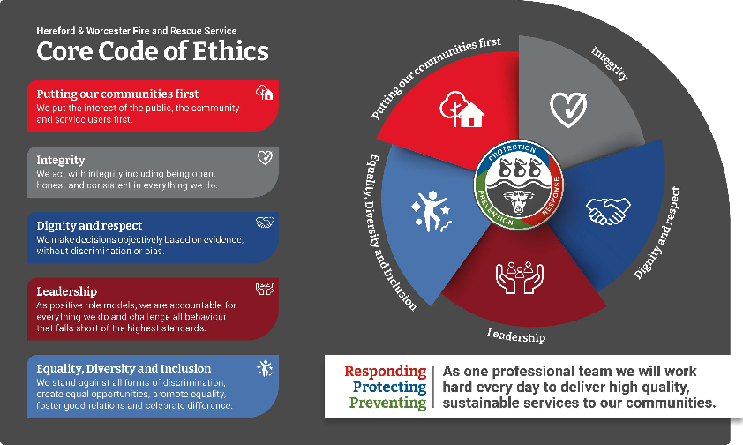

**Safeguarding Policy Statement:**

Safeguarding is everyone’s responsibility, and Hereford & Worcester Fire and Rescue Service (HWFRS) are committed to safeguarding children, young people and adults from abuse and neglect. The Service strives to promote the safety, dignity and wellbeing of staff and people in the community.

Safeguarding practices within HWFRS align to the Safeguarding Fire Standard which aims to ensure that Service support and promote the safeguarding of those within the community, employees and volunteers.  [Safeguarding - Fire Standards Board](https://www.firestandards.org/standards/approved/safeguarding-fsd-pre02/#:~:text=A%20fire%20and%20rescue%20service,of%20abuse%2C%20harm%20and%20neglect.)

All HWFRS staff will adhere to the Service’s Adult Safeguarding Policy and Children and Young People Safeguarding Policy and associated Guidance’s.

[SPI Management & Administration Site - D - Personnel - AllItems (sharepoint.com)](https://hwfire1.sharepoint.com/sites/SPIManagementSite/D%20%20Personnel/Forms/AllItems.aspx)

**Alternative Formats**

If you require this document in another format please contact the Human Resources and Development Department.

Procurement Guidelines

1. Introduction to Procurement

The information contained within this document is intended to provide strategic guidance for all employees that are involved in the procurement and the use of, goods and services secured by the Fire and Rescue Authority (FRA).

1. Procurement

# The Hereford & Worcester Fire and Rescue Authority has defined procurement as:

## ‘The process of securing goods and services whilst ensuring that organisational needs are met within the framework of the policies and strategies of this Authority, with due consideration of financial constraints and within the legal requirements of the Best Value process’.

1. Procurement Guidelines

The FRA’s Procurement Guidelines is an evolving document that will be influenced by the FRA’s Strategy and Performance Planning, IRMP, Best Value Reviews, internal and external Audits, Commission for Racial Equality Guidelines for Public procurement, ODPM Reports.

Officers responsible for the procurement of goods and services are to consider the procedures detailed within the Audit Commissions publication for procurement within the Fire Service; A Uniform Approach – A Study of Fire Service Procurement’, any ‘National’ Procurement Strategy or initiative i.e. the Integrated Clothing Project, the potential for ‘Regional Procurement’ and any other factors impacting upon the Service.

1. Aims and Objectives

Our strategic aims and objectives are to provide a co-ordinated central procurement function which will be responsive to ‘National’, ‘Regional’ and ‘Local Procurements’, aimed to address the needs of the Service, our customers and the end-users, taking account of long term objectives:

Ensure that the most appropriate method is adopted throughout the procurement process, giving due regard to financial regulations/cost/priority/risk; For example, use of “best fit” mechanisms.

Develop an influential and recognised centre of expertise calling upon qualified specialists to provide advice to Practitioners and review the impact of new issues; For example, e-commerce and above the thresholds set out in Public Procurement Regulations 2024 as amended or updated* (“the Public Procurement Thresholds”)

Work towards open and transparent two way communication between suppliers, customers and stakeholders.

Identify methods of improving performance in terms of efficiency, effectiveness and economy.

Obtain appropriate feedback from all interested parties as a mechanism for monitoring the performance of goods and services secured in order to ensure continuous improvements.

Support strategies and policies of the FRA ensuring compliance with corporate standards; for example, Health & Safety and LA 21.

Investigate collaborative working with any future Fire Service National provider, Regional Partners and any other external organisationswhere appropriate.

Produce and disseminate clear guidelines thus ensuring the principles of Best Value including competition are integral to the procurement process, which the principles of project management are adhered to within the procurement process and the production of the required documentation for the Principal Managers Team and the FRA as appropriate.

1. Determining the Procurement Path

The required documentation for the procurement of goods and services will vary according to the strategic importance or value of the goods or services concerned. Strategically important purchases will be critical for giving effect to a statutory duty, risk critical and/or, have the capacity to significantly disrupt Service delivery.

In order to ensure effective procurement, it will be necessary to classify goods or services in relation to their strategic importance/value. Correct classification provides an opportunity to prevent the waste of resources in conducting extensive research into goods or services that are of low financial value/strategic importance, such as standard consumable items.

However, when procuring items of high importance or high value items, there is a need to carry out suitable and sufficient research and market evaluation in order that the service can support the procurement of the item/s.

In order to assist personnel considering the preparation of documents in support of specific procurement, attention is drawn to the exhibit below:

|  |  |  |  |  |
| --- | --- | --- | --- | --- |
| **Complexity of the supply market** | | | | |
|  | Low | | High | |
| High | Procurement Focus  Leverage items | Time horizon  Varied, typically 12-24 months | Procurement Focus  Strategic Items | Time horizon  Up to 10 years; governed by long term strategic impact (risk & contract mix) |
| Importance of the item | Key Performance Criteria  Cost/price and materials flow management | Items Purchased  Mix of commodities and specified materials | Key Performance Criteria  Long- term availability | Items Purchased  Scarce and/o high value materials |
| Typical Sources  Multiple suppliers, chiefly local | Supply  Abundant | Typical Sources  Established global suppliers | Supply  Natural scarcity |
| Procurement Focus  Non critical items | Time horizon  Limited, normally 12 months or less | Procurement Focus  Bottleneck items | Time horizon  Variable, depending on availability vs short term flexibility trade offs |
| Key Performance Criteria  Functional efficiency | Items Purchased  Commodities, some specified materials | Key Performance Criteria  Cost management & reliable short-term sourcing | Items Purchased  Mainly specified materials |
| Low | Typical Sources  Established local suppliers | Supply  Abundant | Typical Sources  Global, predominantly new suppliers with new technology | Supply  Product based scarcity |

Kraljic Portfolio Purchasing Model (1983)

By establishing the appropriate classification of strategic importance personnel will be in a position to identify the appropriate steps that must be taken and the required documentation procurement. The following sections provide additional guidance on items of high strategic importance/value and for low strategic importance/value items. The appropriate ‘budget holder’ will be advised should personnel preparing procurement documents be unsure as to what steps and documents are required in order to support the securing of the proposed goods or services.

1. Procurement Guidance Library

# The following documentation ([on SharePoint](https://hwfire1.sharepoint.com/sites/ProcurementSite/)) is intended to support all levels of procurement and contract management activities and to help manage the expectations of stakeholders, customers and suppliers alike. It facilitates best practice and consistency across Herefordshire and Worcestershire Fire and Rescue Service.

# The [Steps for Procurement](https://hwfire1.sharepoint.com/sites/ProcurementSite/Procurement%20Documents/Forms/AllItems.aspx?id=%2Fsites%2FProcurementSite%2FProcurement%20Documents%2FSteps%20For%20Procurement%20v1%2E2%2Epdf&parent=%2Fsites%2FProcurementSite%2FProcurement%20Documents) document provides one source of guidance and documentation HWFRS which will be updated on a continual basis with any changes in legislation, policy and facilitates best practice and consistency. We would encourage you to use the source documentation for every procurement exercise to ensure you are always using the most recent guidance and templates on an ongoing basis.

Within the site is a mandatory form for completion in all future procurements: [Procurement Stage 1](https://hwfire1.sharepoint.com/sites/ProcurementSite/Lists/Procurement%20Stage%201/NewForm.aspx?Source=https%3A%2F%2Fhwfire1.sharepoint.com%2Fsites%2FProcurementSite%2FLists%2FProcurement%2520Stage%25201%2FAllItems.aspx&ContentTypeId=0x0100C419B5B755123148A3BE1CD7AC106136&id=%2Fsites%2FProcurementSite%2FLists%2FProcurement%20Stage%201). This form will be the start of any procurement as it will ensure documented evidence for pre-contract activities such as planning, identification needs, analysis and sourcing.

Fire and Rescue Service personnel requiring further information are advised to contact the Procurement and Contracts Manager on [procurement@hwfire.org.uk](mailto:procurement@hwfire.org.uk) and visit the [Procurement and Contract Page](https://hwfire1.sharepoint.com/sites/ProcurementSite/) on SharePoint.